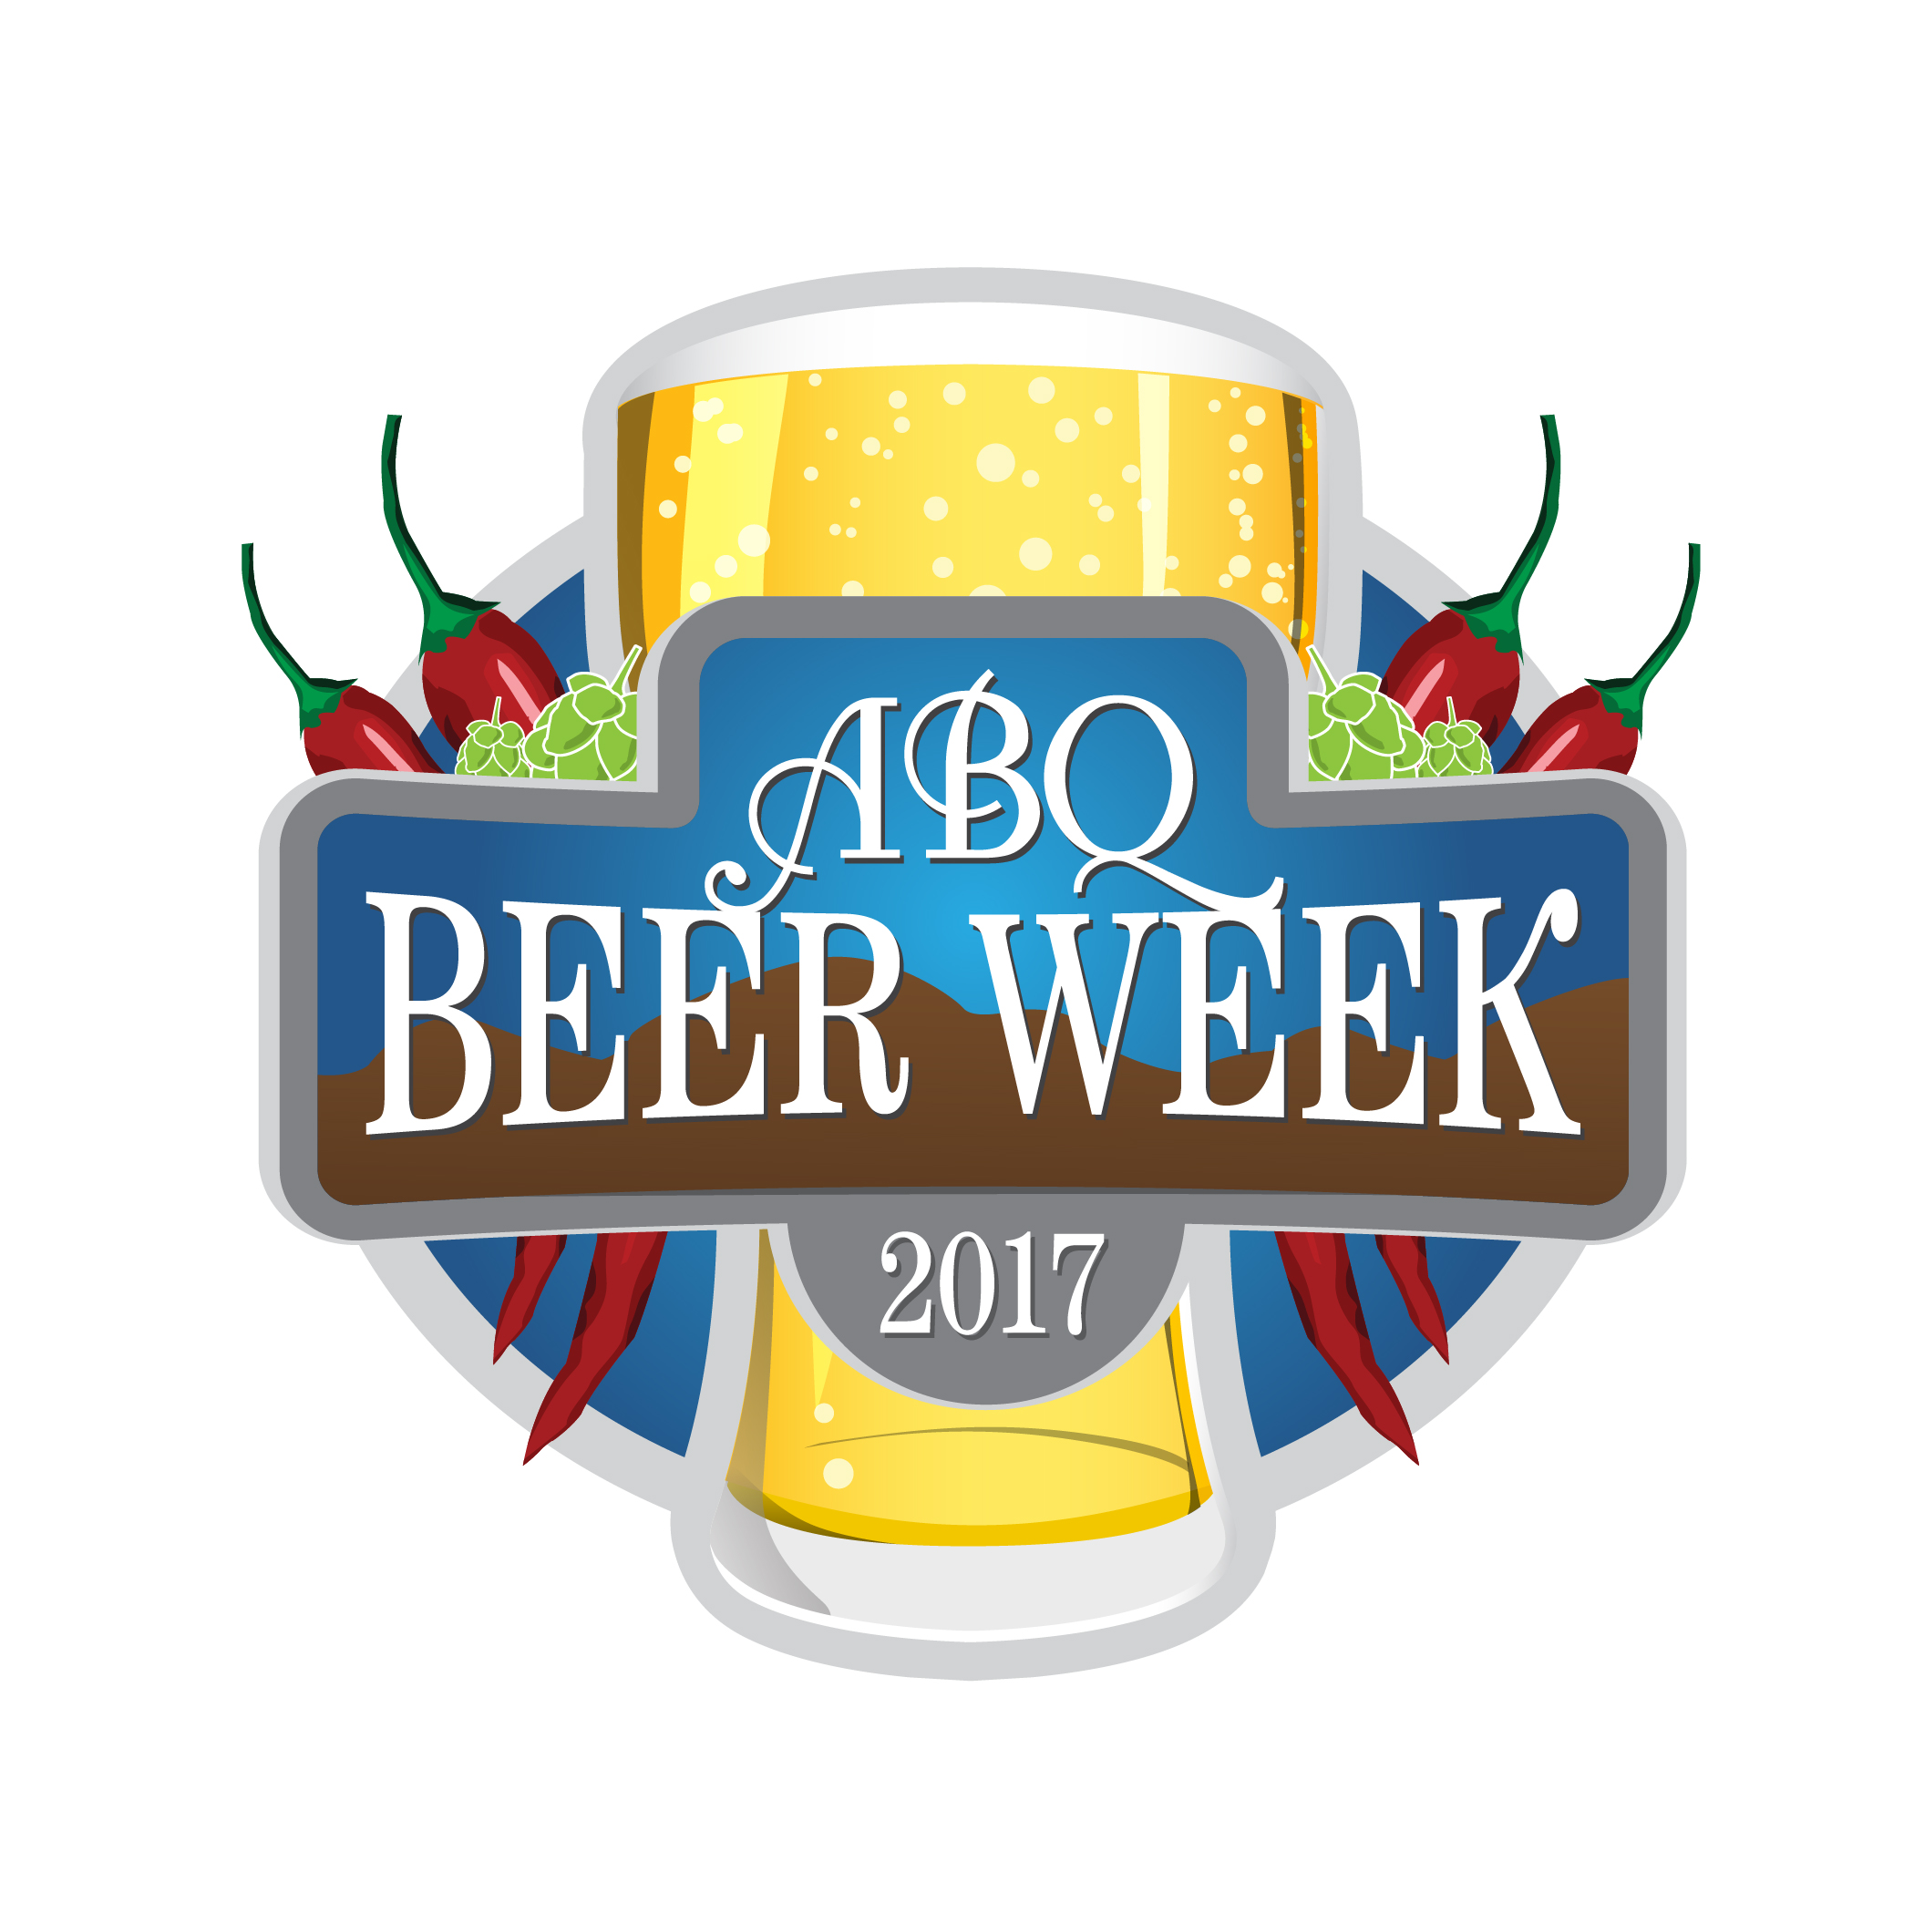
Information Sheet
7th Annual Albuquerque Beer Week
12,000 Beer Lovers, 11 Days, 170 Events, 60 Venues,
When: May 25th – June 4th
Website – www.abqbeerweek.com

